Unit 6.1 APQB Balance of Payments

- The table gives the values of selected accounts in a nation’s balance of payments in millions of dollars.
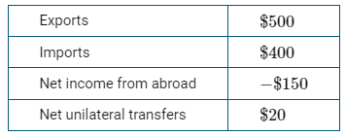
Based on the table, which of the following describes the balance in the current account and in the capital and financial account?
- The current account is in surplus and the capital and financial account is in surplus.
- The current account is in surplus and the capital and financial account is in deficit.
- The current account is in deficit and the capital and financial account is in surplus.
- The current account is in deficit and the capital and financial account is in deficit.
- The current account is in surplus and the capital and financial account is zero.
- Which of the following is recorded in a country’s current account?
- The value of goods produced and consumed in the country
- The value of domestic financial assets sold to foreign investors
- The value of foreign bonds purchased by the country’s residents
- The value of consumer goods produced abroad and purchased by the country’s residents
- The value of the country’s government bonds purchased by the country’s central bank
- The table gives the values of selected accounts in a nation’s balance of payments in millions of dollars.
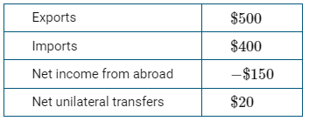
Based on the table, the nation’s trade balance is equal to which of the following?
- −$130 million
- −$100 million
- $100 million
- $770 million
- $900 million
- Which of the following transactions would increase the current account surplus in Japan’s balance of payments accounts?
- A Japan-based company sells roasted coffee to Canada.
- Mari, a Japanese investor, buys stocks in a Japanese company.
- Bob, a Canadian, buys stocks in a Japanese company.
- A Japan-based company buys a piece of equipment from Germany.
- Artois, a French citizen, works at a Japanese company in Paris.
- Assume Country X has the following international transactions, in billions of dollars, during a given period of time.
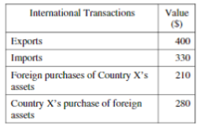
What is the balance on the current account, in billions of dollars, for the period?
- -140
- -70
- -0
- +70
- +140
- Which of the following is true of a current account deficit?
- It is caused by a trade surplus.
- It must be financed with an equally large surplus of exports.
- It is caused by a deficit in the financial (capital) account.
- It will self-correct in the following year.
- It is financed by a surplus in the financial (capital) account.
- An increase in a country’s current account surplus will result in which of the following in the short run?
- A decrease in the country’s government budget surplus
- A decrease in the country’s national savings
- A decrease in the country’s financial account deficit
- An increase in the country’s net financial capital outflows
- An increase in the country’s national debt
- Which of the following transactions is included in the financial account of Country X’s balance of payments accounts?
- A firm in Country X sells robots to a firm in Country A.
- Country X sends financial aid to Country B.
- An individual in Country X receives dividend payments from a firm in Country C.
- An individual in Country X sends money monthly to family members in Country D.
- An individual in Country X buys new government bonds issued by Country E.
- Which of the following would decrease the United States net exports to South Korea?
- South Korean computer companies sell more computers to the United States.
- South Korean insurance companies provide fewer services to the United States.
- South Koreans spend more vacations in the United States.
- United States banks provide more banking services to South Korea.
- United States smartphone companies sell more smartphones to South Korea.
- If consumers in Canada increase their demand for products that are manufactured in India, which of the following will occur?
- The Indian rupee will depreciate.
- The Canadian dollar will appreciate.
- India’s financial capital inflow will increase.
- Canada’s financial capital inflow will increase.
- The supply of Canadian dollars will decrease.
- A country can have an increased surplus in its balance of trade as a result of
- an increase in domestic inflation
- declining imports and rising exports
- higher tariffs imposed by its trading partners
- an increase in financial capital inflow
- an appreciating currency
- Singapore and Japan are trading partners. The Japanese economy is operating at full employment, and Japan’s current account balance is zero.
- Assume the exchange rate between the Singapore dollar (SGD) and the Japanese yen (JPY) changes from 1 SGD = 82 JPY to 1 SGD = 65 JPY. Does the JPY appreciate or depreciate against the SGD?
- Given your answer in part (a), will each of the following increase, decrease, or remain the same?
- The price of Japanese goods in Singapore dollars
- Japan’s net exports
- Draw a single correctly labeled graph with the long-run Phillips curve and short-run Phillips curve for Japan. On the graph, show the new short-run equilibrium as a result of the change in Japan’s net exports from part (b)(ii), labeled point X.
- Given your answer in part (b)(ii), will each of the following be in deficit, surplus, or zero for Japan?
- Current account balance
- Financial (capital) account balance

Answer
1. C 2. D 3. C 4. A 5. D 6. E 7. D 8. E 9. A 10. D 11. B

12

Answer
1. C 2. D 3. C 4. A 5. D 6. E 7. D 8. E 9. A 10. D 11. B
A 1 point is earned for: stating that JPY appreciates relative to the SGD.
B 1 point is earned for: stating that the price of Japanese goods in Singapore dollars will increase.
1 point is earned for: stating that Japan’s net exports will decrease.
C 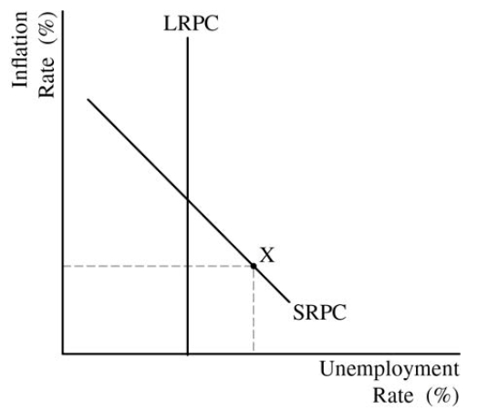
D 1 point is earned for: stating that Japan’s current account balance will be in deficit and that Japan’s financial (capital) account balance will be in surplus.

